CST 2309 Lab 13.1 – Maximo A.

Refer to Chapter 6: Enhancing and Validating Forms

Add a screenshot of the js06a.html displayed in the browser as shown in Figure 6-21 on page 226 after completing Step 2

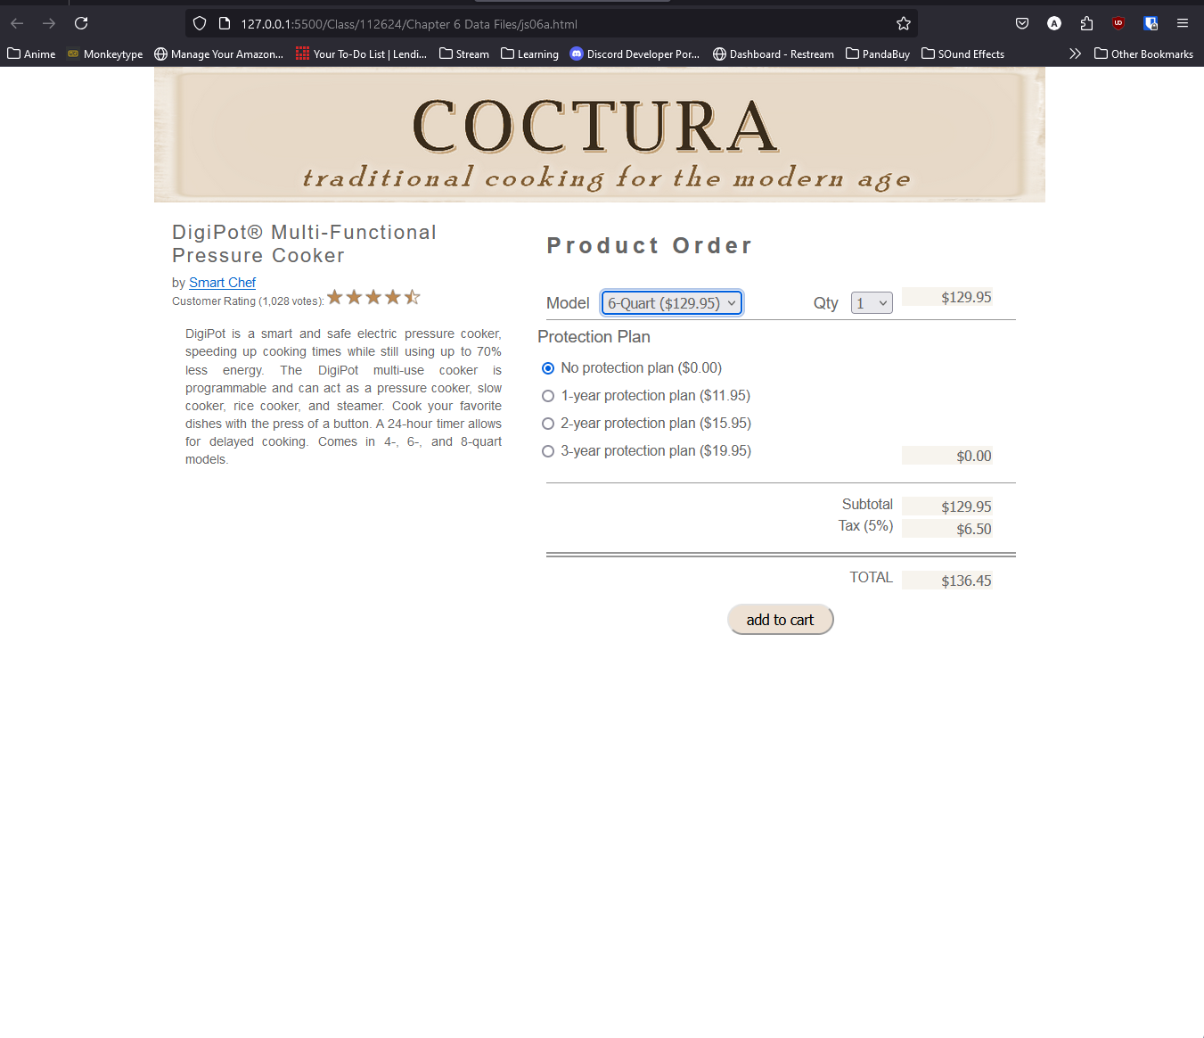

Answer the following questions:

1. Provide the object reference to the second element within the first web form on the web page.

document.forms[0].elements[1];

1. Provide code to retrieve the value of the selected option in the selection list with the id “state”, storing the value in the stateName variable

let stateName = document.getElementById(“state”).value;

1. Provide code to retrieve the value of the checked option in the option group for the shipping field.

document.querySelector(‘input[name=”shipping”]:checked’).value;

1. Provide code to display the value of the payment variable as United States currency.

Payment..toLocaleString("en-US", {style: "currency", currency: "USD"})

1. Provide code to run the calcShipping() function when the value of the state field in the shoppingCart form is changed.

for (let i = 0; i < document.forms[“shoppingCart”]..elements.length; i++) {

document.forms[“shoppingCart”].elements[i].addEventListener("change", calcShipping);

}